ASR BD RF Picking – Manual Pick

Date: 23 Oct 2014

Current issue:

Lacking of pick item pansize information on the RF Picking. Picker would like to consolidate picking of loose cartons pick at once and then picking of full Pallet item or verse versa.

Current directed pick do not have such flexibility.

Change Request:

Picker request pick qty to add conversion of carton/pallet and display pansize in order to ease picking process.

Picker also request to have free control on picking sequence instead of follow system directed pick.

1. RF Directed Pick –

To add on display Pick qty in Carton/Pallet and the Part’s pan-size conversion.

RF Pick screen with added Qty information as below :

Added converted Carton / Pallet

And pansize: C = Carton, P = Pallet

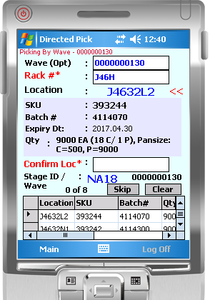

1. RF Manual Pick – [added request 30 Oct]
   1. to add pick by Wavekey,
   2. To add display Pick qty in Carton/Pallet and the Part’s pansize conversion

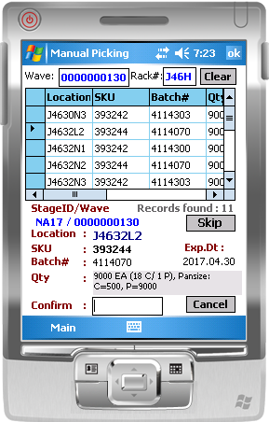

Qty pick with converted # of Carton (C) and # of Pallet (P), and the pan-size.

Added Wavekey